

**Faculty of engineering - Shoubra**

**Benha University**

|  |  |
| --- | --- |
| **Department** | **Engineering Mathematics and physics** |
| **Division** | **----------** |
| **Academic Year** | **2019-2020 Preparatory** |
| **Course name** | **Computer** |
| **Course code** | **ECE001** |

**Title: -**

**Artificial Intelligence**

By:

|  |  |  |  |
| --- | --- | --- | --- |
|  | Name | Edu mail | B.N |
| 1 | يوسف محمد امين امين | youssif196205@feng.bu.edu.eg | 1072 |

**Approved by:**

|  |  |
| --- | --- |
| Examiners committee | Signature |
| Dr. Ahmed Bayoumi |  |
| Dr.Shady Elmashad |  |
| Dr. Abdelhamid Attaby |  |

**Application brief:**

Artificial intelligence (AI) is the ability of a computer program or a machine to think and learn. It is also a field of study which tries to make computers "smart". They work on their own without being encoded with commands. John McCarthy came up with the name "Artificial Intelligence" in 1955.

In general use, the term "artificial intelligence" means a program which mimics human cognition. At least some of the things we associate with other minds, such as learning and problem solving can be done by computers, though not in the same way as we do. Andreas Kaplan and Michael Heinlein define AI as a system’s ability to correctly interpret external data, to learn from such data, and to use those learnings to achieve specific goals and tasks through flexible adaptation

**Screen shots**

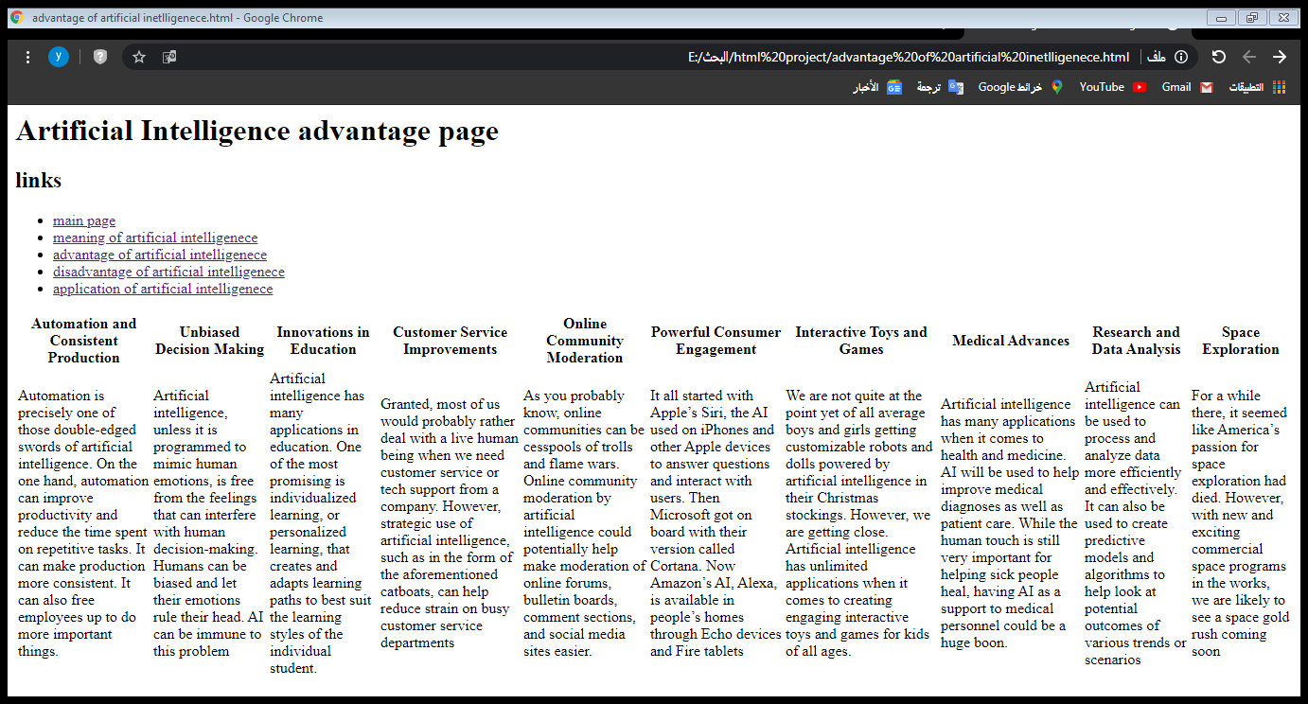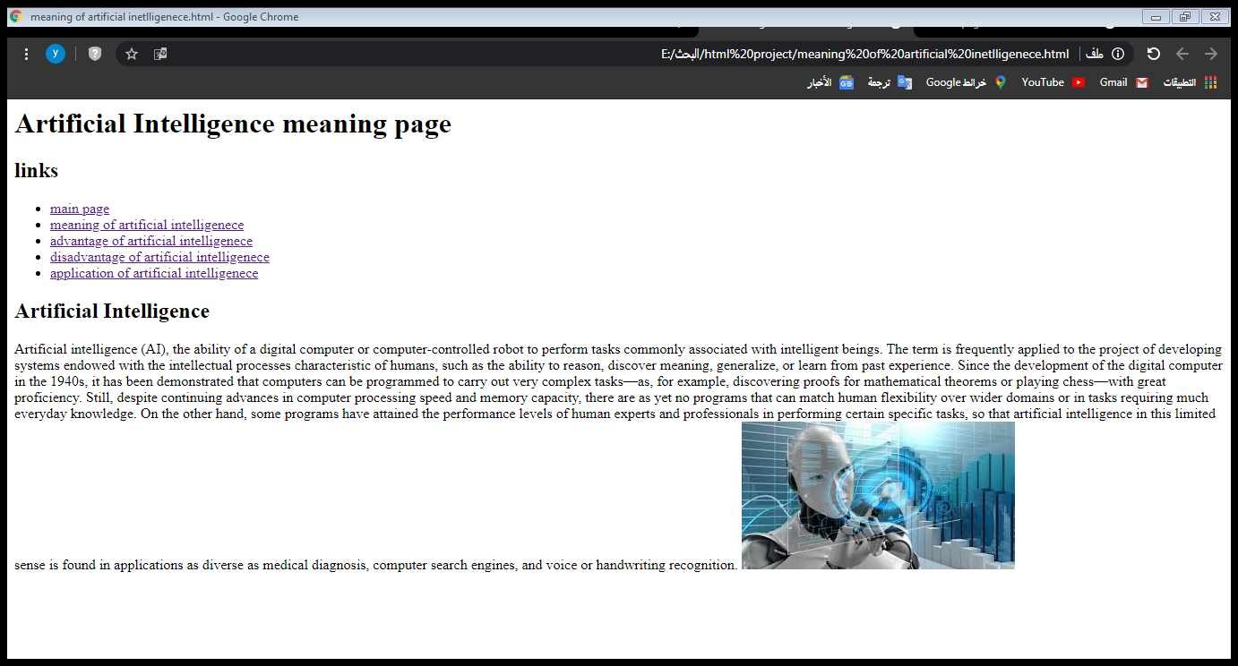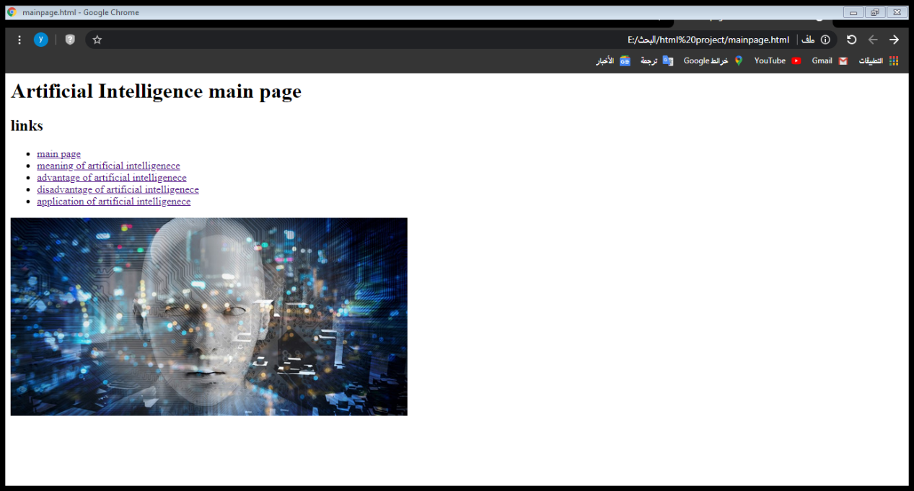

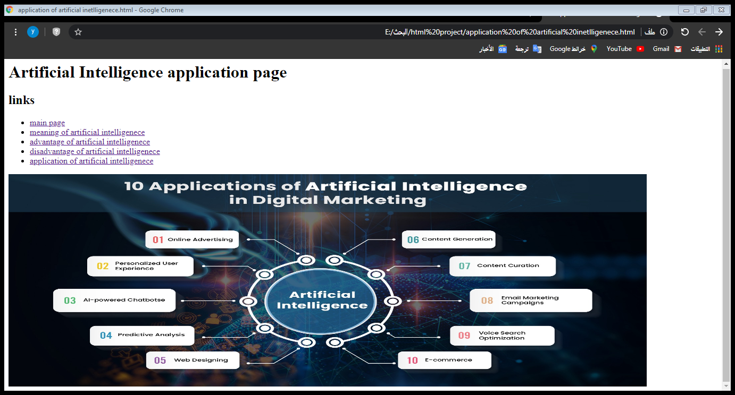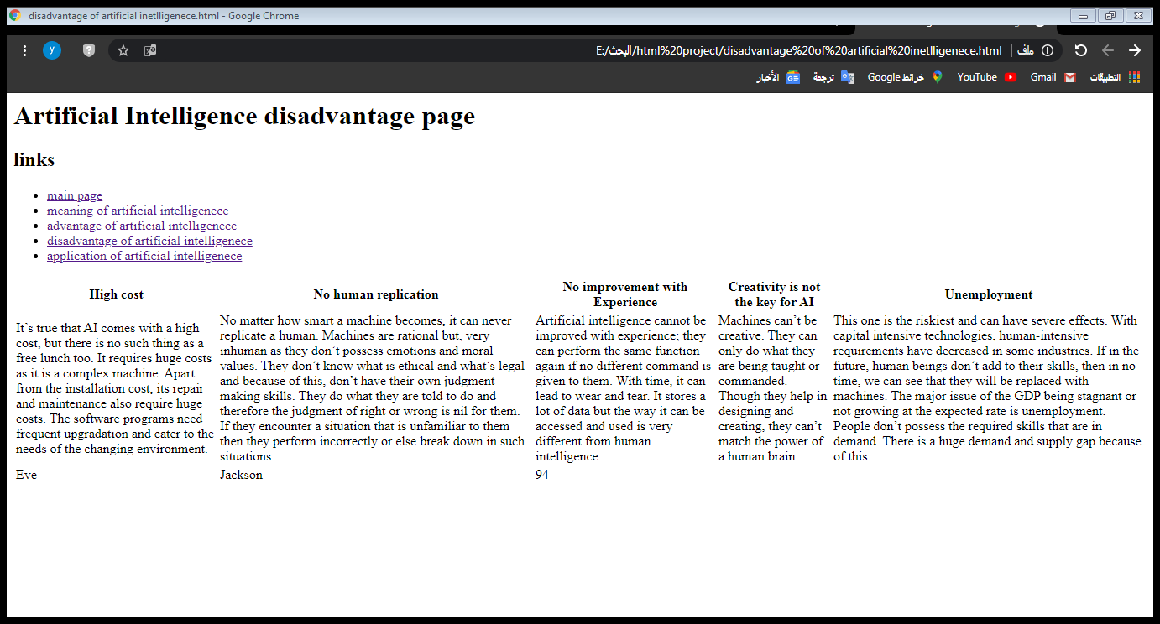

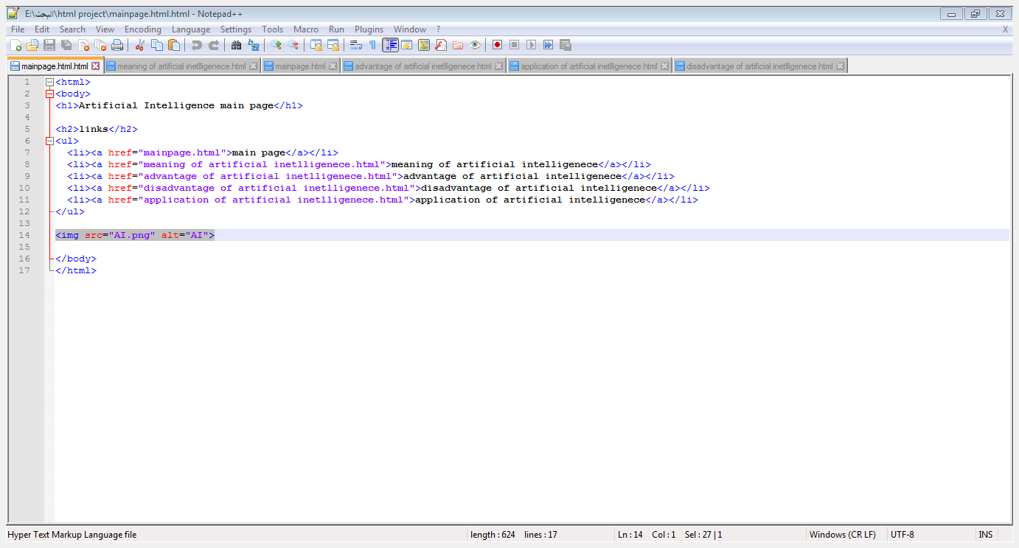**Source code:**

